**SOFTENG 350**

**Tutorial 3: Contextual Inquiry**

**Worth 1% of your final grade**

**Tutorial exercises should be undertaken in pairs**

**Each partner must fill out their own worksheet, in their own words**

**You should plan to spend 40 minutes on this tutorial**

**Upload your completed worksheet to Canvas**

**Due in your tutorial, or by 6pm on Friday 27 March**

**Aims**

The aim of this assignment is to give you experience in performing contextual inquiry for alarm use.

**Background**

Your task is to undertake contextual inquiry of a person’s use of alarms. An example of use may be mobile (like the Clock-Alarm function highlighted from this iPhone).

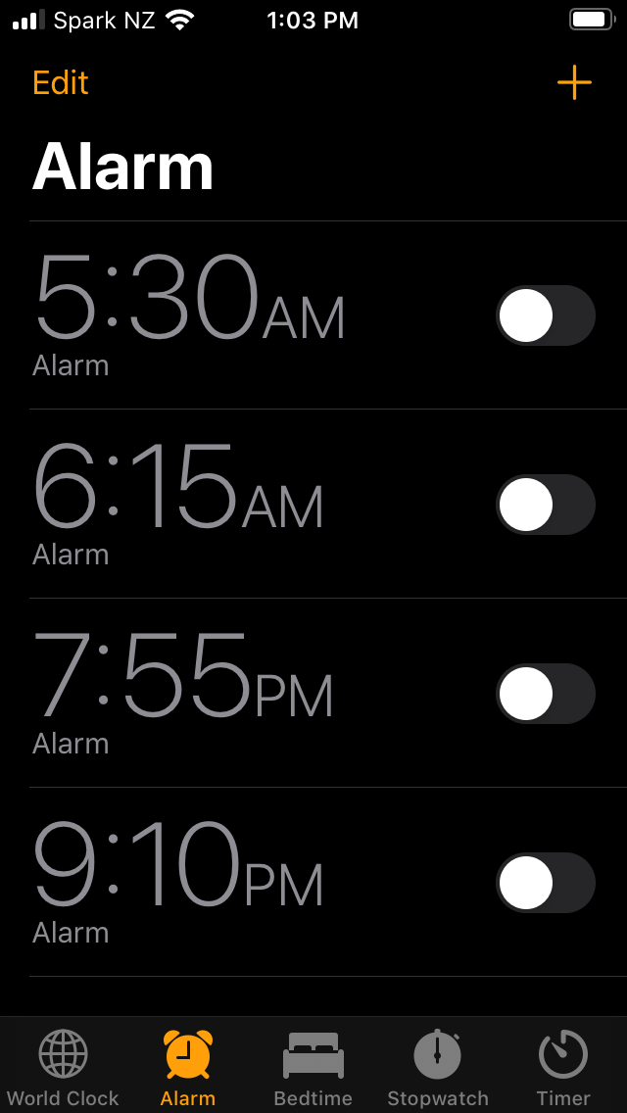

We will follow the contextual inquiry approach described in lectures and from the reading of Chapter 7.

**Activity 1**

In your pair, take turns to understand your partner’s work practice in the use of alarms, with particular focus on mobile alarms used, if any. Interview them on their use of alarms in general, and if any alarms are enabled by mobile apps. Contextual inquiry is ideally observed in the actual time and setting of use. For this tutorial, observe any apps used, settings of apps used and ask questions to understand the full scope of their work practice for the apps. For example, questions around differences in use for personal and university activities, or changing use patterns for special times in the year (e.g., their birthday), variations in reactions to alarms, where the phone is kept while sleeping or other times/settings, what works well and any frustration points.

Before you start the interview, observation and questioning you should ensure you are familiar with the domain, terminology used for alarm functions, other alarm products on the market, etc.

In your writeup below first document what you identified from the familiarisation process for alarm apps. Then document your notes from the interview and observations from your partner’s mobile. Photos of your partner’s apps (if any) may be included. Bullet points may be used for the writeup. Aim to write 200-300 words.

|  |
| --- |
| **Data from the familiarisation process**  **Notes from interview and observation of partner’s work practice** |

**Tutorial 3 Worksheet Rubric**

*Criteria*

* Domain knowledge: Comprehensiveness of knowledge of the alarm function domain.
* Work practice observation: Depth of understanding of your partner’s work practice.
* Overall quality: Clarity of writing / descriptions and professionalism of the presentation.

*Assessment of criteria*

Criteria are assessed as excellent, good, satisfactory, unsatisfactory or fail. A letter grade is assigned based on holistic assessment of the categories.

Lots of different styles for alarm clocks. There are many ways to dismiss alarms: solve puzzles, shake the phone, take a specific photo. Notification is also another variable in alarms. Some use songs as alarms, podcasts, annoying sounds, vibration, popups. One-time vs recurring alarms. Some are specialized for just sleeping, waking people up at the correct time in the sleep cycles. Reminders are a sort of specialized alarm. There are some apps which are extremely customizable allowing changes to snooze behaviour and notification behaviour.

They use alarms, use to wake up. Recurring alarm each week. Really hard trouble waking up. Sometimes use one offs such as exams and assignments. Do not use alarms outside of mobile. Use annoying music to get up immediately. Has tried out 2 alarm apps. Use google assistant(reminder) and default clock app on phone. No dark mode feature available but is desired. Only recently started using reminders app but plan to use for university assignments. Frustrated no dark mode (burns eyes when going to sleep/ waking up). Keep phone 10m away from bed to force getting up and turn off alarm. The only options for recurring alarms is by setting the weekly schedule, and this weekly schedule will repeat.

